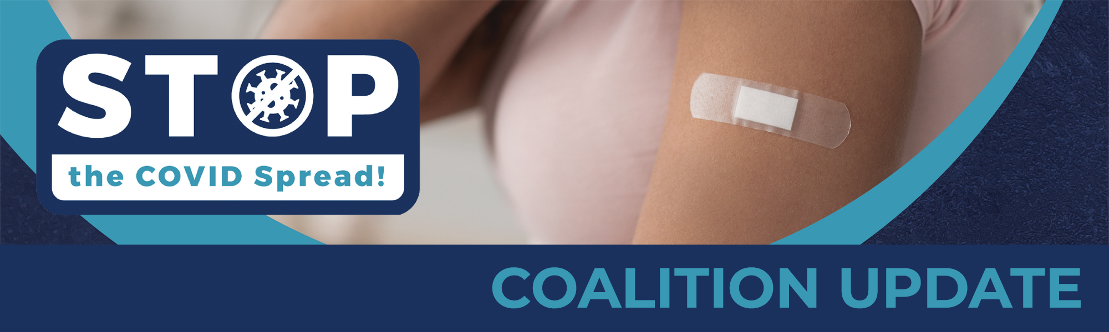

(Insert greeting to appropriate audience)

What a summer it has been. Many of us have emerged out of strict quarantines and hard times with a renewed spirit and fresh perspective on the things that matter most. After getting a taste of normalcy again, it feels like we’re near the finish line. But unfortunately, our battle with COVID is far from over.

Recently, the tides have shifted with increased spread of COVID-19 caused by the Delta variant. Cases around the country have rapidly increased as well as reports of hospitalizations, and in severe cases, death. We are in a race to increase vaccination quickly enough to prevent the Delta variant from sending us back to where we were in 2020.

As leaders of the community, it’s our duty to link arms with one another for the greater good: to do everything in our power to slow the transmission of this awful virus in order for us to flourish and move past these hard times. Of the many things we can do right now, the most important is to encourage people to get vaccinated. I encourage you to talk to family and friends about COVID-19, to learn and educate yourselves on the facts through credible sources, and to speak with doctors and trusted healthcare experts about the matter.

Thankfully, these vaccines are trustworthy and safe. They have been vouched for by experts, approved by the FDA, and proven effective through various methods of safety tracking and monitoring in place such as the Vaccine Adverse Event Reporting System (VAERS) and Vaccine Safety Datalink (VSD). Plus, it’s encouraging to know 96% of practicing physicians are vaccinated, demonstrating to us the level of vaccine credibility and trustworthiness.

Receiving a vaccine is easy to accomplish with such widespread availability of vaccination appointments–and they’re free to all. This incredibly crucial defense to the virus decreases the risk of severe illness and hospitalization altogether with vaccinated individuals being 89-100% less likely to be hospitalized or die from COVID-19.

Now is the time to work together to stop the spread of this relentless virus – and it begins with you! You have the opportunity to make a huge impact in the lives of your family, friends, and community members alike by seeing that those around you protect themselves and others through vaccination. Let’s create a safer tomorrow for everyone by encouraging folks to vaccinate.

For more information on slowing the spread of COVID-19, click here.

Sincerely,

(Coalition Member Leader Name)
(Coalition Member Leader Title)
(Coalition Member Logo)

Don’t wait. Vaccinate.

